You will never look at
Snow hills the same again!



Come to visit
The biome of Chewandswallow

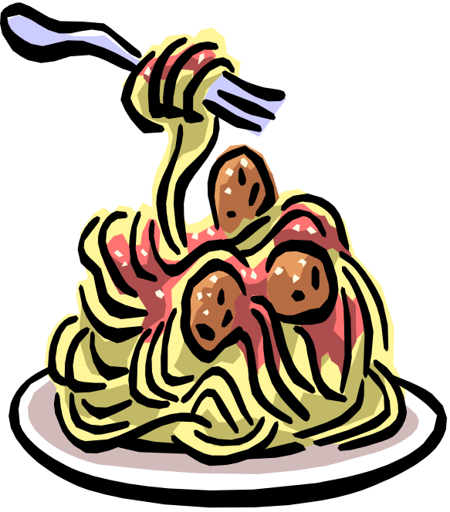

You will see many great things in Chewandswallow

- Clouds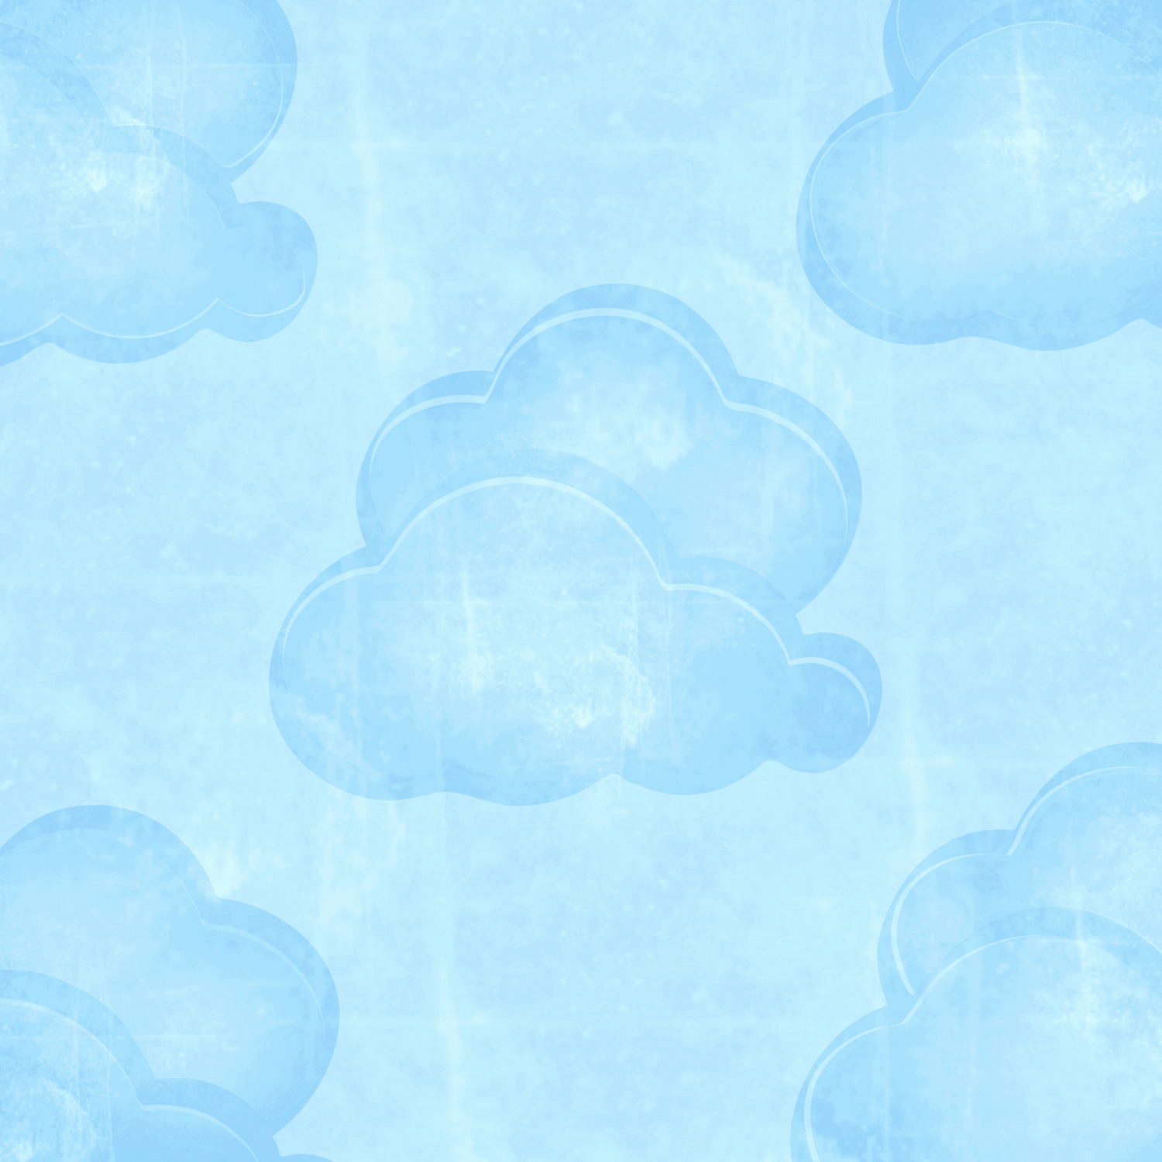
- It will actually rain FOOD!!!!
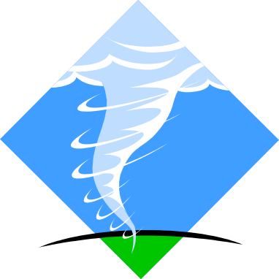
- Tomato tornadoes!
House Covered Pancakes!!!!!
- 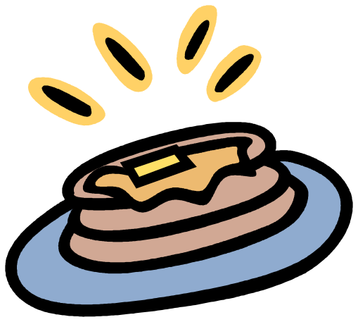

It is guaranteed to rain:
Orange Juice
Hot Dogs
Pizza
Pickels

Storms of hamburgers
- 

